Feedback form - holding oprichten
- Aanvraagtype
  - maybe we can skip this question?
and it will also be easier for next step that they can select their only shareholders' order, so maybe the logic in oprichting document also needs to be changed that they can choose if the shareholder is a rechtspersoon or a natural person?
- Oprichting document (holding)
  - first ask the shareholders and then ask about the bv address
otherwise, clients might be confusing about if there are more naturalijke persoon be one of the shareholders and would like to use that address
  - there is o information can be filled in when i choose there is a boekhouder/accountant
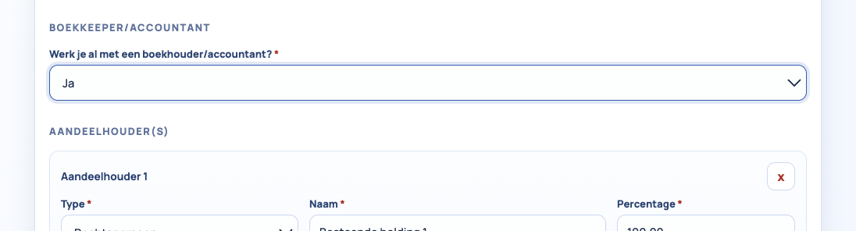
  - Here is a problem, automatically the rechtspersoon will be the first shareholder and the name is automatically filled as bestaande holding 1. but sometimes people would like the bestaande holding not to be the first shareholders.
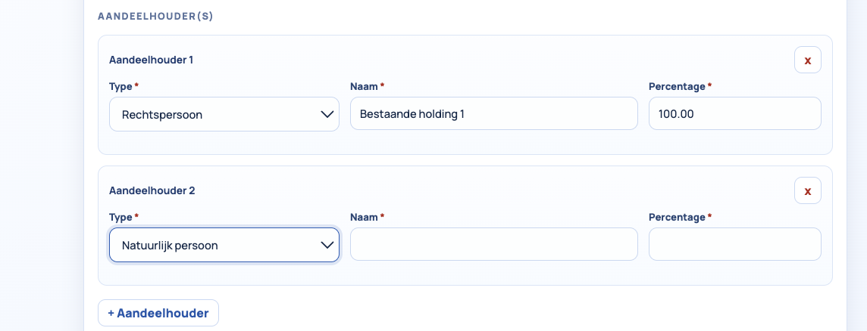
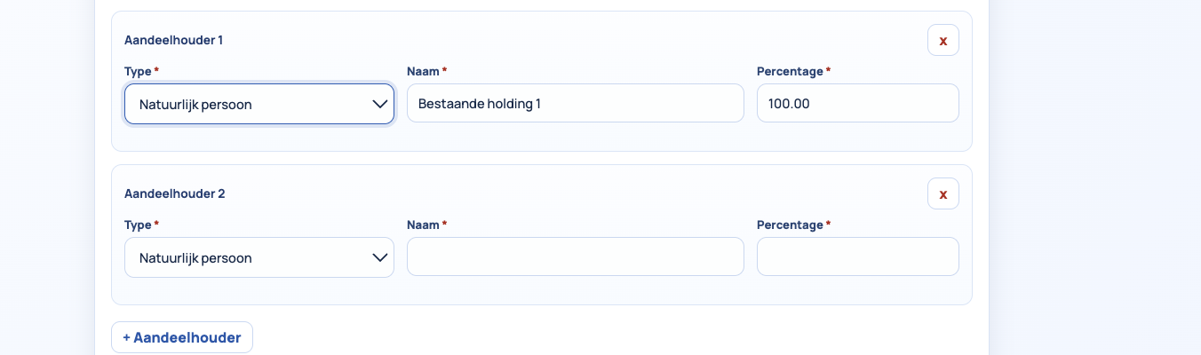
not sure how this can be fixed. main question is how can they choose the order by themselves
- Rechtspersoon
  - for the directeur
    - we need to make it possible for the client to choose if the directeur is a rechtspersoon or it is a natural person, and then ask for the information in rechtspersoon/natural persoon. because currently it is only possible to fill the bestuurder's info as natural person
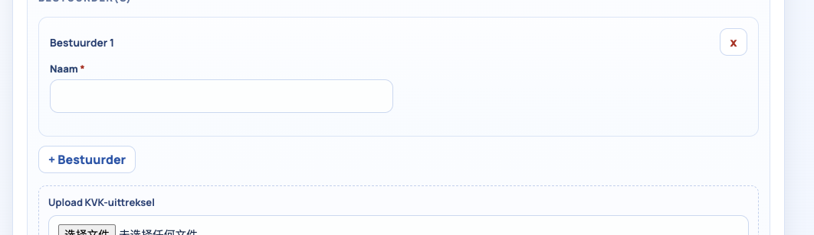
    - only the name of bestuurders are the "required" question which is not correct
- Natuurlijke persoon
  - need to make it impossible to fill in the "Nederland woonadres"
  - need to add a reminder under eenmanszaak "Let op: uw nieuw op te richten B.V. mag niet dezelfde naam hebben als uw bestaande eenmanszaak. Indien beide ondernemingen dezelfde naam hebben, adviseren wij u om de naam van uw eenmanszaak via het online formulier van de Kamer van Koophandel (KVK) te wijzigen, zodat de B.V. zonder problemen kan worden ingeschreven."
  - need to change eenmanszaak into "eenmanszaak/VOF"
  - cannot see which are the "required" questions
- Upload
  - cannot upload multiple files one by one, they need to select at one time, either we need to change to make it possible to upload different files one by one, or we need to write a reminder that they need to select all files together
I prefer the first solution, since the second one will be difficult for some of the phone users
- indienen
  - need to add check box + Ik ga akkoord met de Privacyverklaring, de Algemene Voorwaarden en de AI-verklaring. Tevens bevestig ik dat ik mijn bestelling en gegevens heb gecontroleerd. I agree to the Privacy Statement, the General Terms and Conditions, and the AI Declaration. I also confirm that I have reviewed my order and details. also the attachment/URL of general ters and conditions +privacy statement

